Understanding PCI and PCIe Device Drivers 2
PCI Enumeration 2
PCI Components 2
PCI Address Domain 2
PCI Configuration Address Space 2
PCI Memory Address Space ( Mapping I/O Register as Memory Mapped) 5
PCI I/O Address Space ( Mapping I/O Register as IO Ports) 7
PCIe message space 8
BAR Management and Deciding Prefetchable and Non-prefetchable 8
PCI DMA Access 10
PCIe Port Bus Driver 19
SysFS PCI 20
Manual driver binding and unbinding 21
Writing PCI Device Driver 22
__get_free_page(s) vs. alloc_page(s) 29
LINUX PCI API 30
Exploration of bus/attached devices and drivers 30
Device setup (bus mastering, enable/disable) 30
Power Management related functions 30
PCI memory pools (consistent DMA mappings...) 31
Configuration space access 31
SETPCI Command 32

Understanding PCI and PCIe Device Drivers
PCI (66Mhz) and PCIe 3.0 (8Ghz), PCIe supports hardware I/O virtualization.

PCI Enumeration
When power is applied to a PCI device, the hardware remains inactive. In other words, the device responds only to configuration transactions. At power on, the device has no memory and no I/O ports mapped in the computer's address space; every other device-specific feature, such as interrupt reporting, is disabled as well.

Fortunately, every PCI motherboard is equipped with PCI-aware firmware, called the BIOS, NVRAM, or PROM, depending on the platform. The firmware offers access to the device configuration address space by reading and writing registers in the PCI controller.

At system boot, the firmware (or the Linux kernel, if so configured) performs configuration transactions with every PCI peripheral in order to allocate a safe place for each address region it offers.

By the time a device driver accesses the device, its memory and I/O regions have already been mapped into the processor's address space. The driver can change this default assignment, but it never needs to do that.

PCI Components
Root complex
connects the CPU and memory to the PCIe switch or Endpoint
Switch
is a logical assembly of multiple PCI-to-PCI Bridge devices
There are one upstream port and some downstream ports.
Endpoint
can be the Requester or Completer

PCI Bus Enumeration
Since there is no direct method for the BIOS or operating system to determine which PCI slots have devices installed (nor which functions the device implements) the PCI bus(es) must be enumerated. Bus enumeration is performed by attempting to read the vendor register and device ID register for each combination of bus number and device number at the device's function #0.After that BIOS Assign I/O and Memory Spaces to BAR of PCI devices

PCI Address Domain

There are four address spaces in PCIe. In contrast, PCI only have three address spaces.
The PCI address domain consists of three distinct address spaces: configuration, memory, and I/O space.
Memory and I/O Space base addresses are present inside BAR registers of Configuration Space. Fourth
Space is PCIe Message Space specific to PCIe.

During the boot time, the BIOS or the OS sets the base address registers (BARs) through configuration space. BARs determine address ranges in I/O or memory space that a device should respond to. Obviously, those ranges should not be duplicated anywhere else in the I/O space or memory space on the same PCI bus.
On all IBM PC-compatible machines, BARs are assigned by the BIOS. Linux simply scans through the buses and records the BAR values.

PCI Configuration Address Space

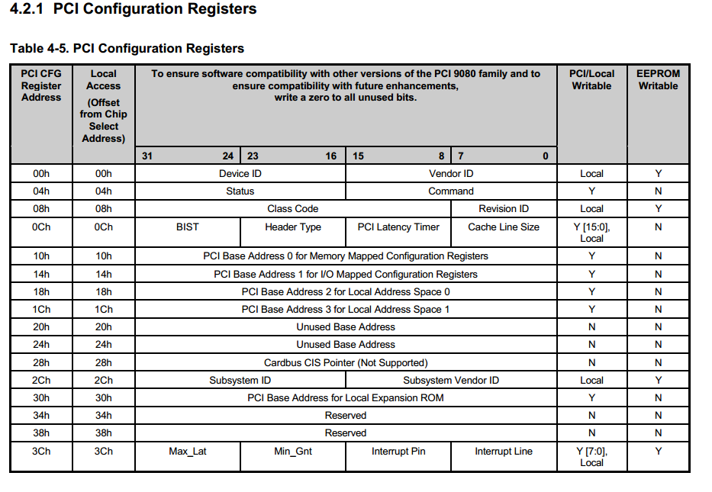
- Each PCI peripheral device contains a set of well-defined configuration registers in its PCI configuration space.
- The registers are used not only to identify devices but also to supply device configuration information to the configuration framework.
- This configuration space is used for auto configuration of inserted PCI cards.
- ‘Base Address’ registers are mapped into Memory Address Space or I/O Address Space.
Bar are used to Map ???

- ‘Configuration Address Space’ has been defined to support PCI hardware configuration.
- The access mechanism for the first 256 registers is the same as in PCI for x64 architecture, i.e., using IO port 0xCF8-0xCFB for address and 0xCFC-0xCFF for data.

- ‘Configuration Address Space’ provides access to 256 bytes of special configuration registers per PCI device.
- The first 64 bytes are standardized, while the rest are device dependent
- PCI Express introduces 'Extended Configuration Space‘ which extends the Configuration Space to 4096 (4K) bytes per Function ( VF and PF).

- Reading and Writing to Configuration Config space are done by
- pci_read_config_word()
- pci_write_config_word()

PCI configuration registers (per-logical PCI device) accessed through two 32-bit ports at I/O port CF8h-CFBh and CFCh-CFFh respectively. Port CF8h-CFBh is the “index” port, used to point to specific 32-bit PCI configuration register within the configuration space. Port CFCh-CFFh is the “data” port, used to write/read to/from PCI configuration register within the PCI configuration space.

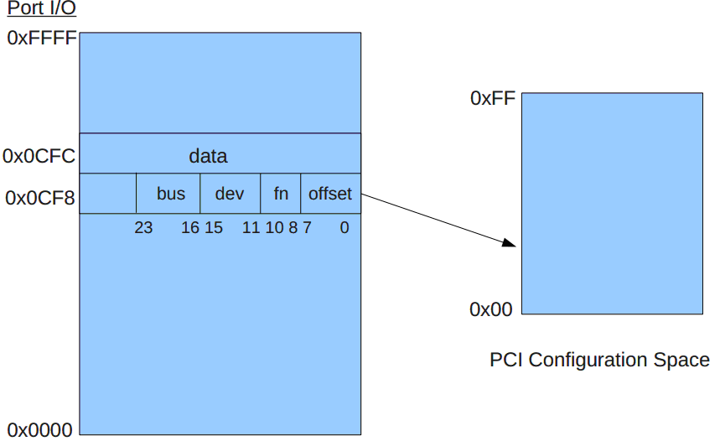

So Basically pci_read/write_config_word is Inb/out operation i.e. accessing through IO command.

#define CONFIG_CMD(dev, where) (0x80000000 | (dev->bus->number << 16) | (dev->devfn << 8) | (where & ~3))

static int pci_conf1_read_config_byte(struct pci_dev *dev, int where, u8 *value)
{
outl(CONFIG_CMD(dev, where), 0xCF8);
*value = inb(0xCFC + (where&3));
return PCIBIOS_SUCCESSFUL;
}
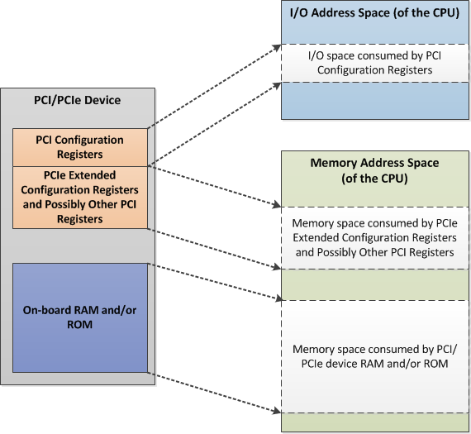

- PCI Configuration Base Address Registers (BAR)
- The PCI configuration space consists of up to 6 32-bit base address registers for each device. System firmware/BIOS assigns base addresses in the PCI address domain to these registers.
- If device is 32-bit capable, then max 6 BARs are possible, but for 64-bit PCI card, only 3 BAR regions are possible.
- Each addressable region can be either memory or I/O space.
- The value contained in bit 0 of the base address register identifies the type.
- Bit 0 in all BARs is read only and is used to determine whether the BARs map to the memory or I/O address space. A value of 0 in bit 0 indicates a memory space (MEM-RESOURCE???) and a value of 1 indicates an I/O space (IO_RESOURCE ???)

BAR Type Memory and I/O
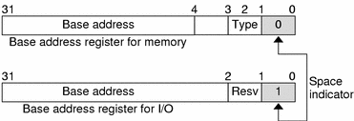

Below Shows output of lspci -x of Sun EDR HCA card
06:00.0 InfiniBand: Oracle/SUN PSIF Dual port EDR Host Channel Adapter (rev 01)
00: 8e 10 88 20 46 01 10 00 01 00 06 0c 40 00 00 00
10: 0c c0 ff f9 00 00 00 00 0c 00 00 f0 00 00 00 00
20: 0c 80 ff f9 00 00 00 00 00 00 00 00 8e 10 00 00
30: 00 00 d0 fb 40 00 00 00 00 00 00 00 ff 00 00 00

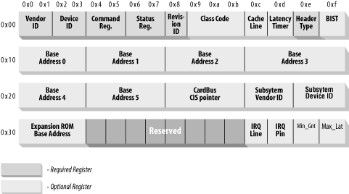

Little Endian

PCI Config Space-Actual 64 bytes
108e - Vendor ID 2088 - Device ID 0c06 - Class Code (IB Device)

f9ffc00c - BAR 0 Address ( 0 Bit at End shows its a a Memory Mapped I/O)

PCI Memory Address Space ( Mapping I/O Register as Memory Mapped)
PCI supports both 32-bit and 64-bit addresses for memory space.
System firmware assigns regions of memory space in the BAR Register of Configuration Register which contains Base address of regions.
Device addresses in memory space are memory-mapped into the host address domain so that data access to any device can be performed by the processor's native load or store instructions.
- ‘Memory address space’ is used for burst transactions.
- ‘Memory Read’ command and ‘Memory Write’ command are used to transfer data in ‘Memory Address Space’.
- readb()/write(),readw()/writew(),readl()/writel()
- cat /proc/iomem will have Memory Address space mapping
- MEM_RESOURCE
- If the PREF (prefetchable) bit is set in the base address bit 3, the memory area
is non prefetchable, in other words data and addressed are dumped directly to the
bus-subsystem. This mode is intended for devices that maps special registers in a
memory area so the CPU can read or write this registers without a PCI-Bridge related
delay.

If the memory region is marked as prefetchable, the CPU can cache its contents and do all sorts of optimization with it; nonprefetchable memory access, on the other hand, can't be optimized because each access can have side effects, just as with I/O ports. Peripherals that map their control registers to a memory address range declare that range as nonprefetchable, whereas something like video memory on PCI boards is prefetchable.

PCIe memory space in this context is the CPU memory space consumed by PCIe devices for non-configuration purposes. For example, the CPU memory space used to store PCIe device data, such as for local RAM in PCIe network controller card or PCIe graphics card local RAM used for graphics buffer.

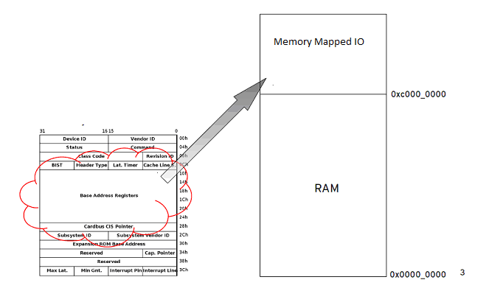

BAR 0 Address Region Mapped to Memory Mapped IO Space

On a memory mapped address type the lower 4 bits have the following meanings:
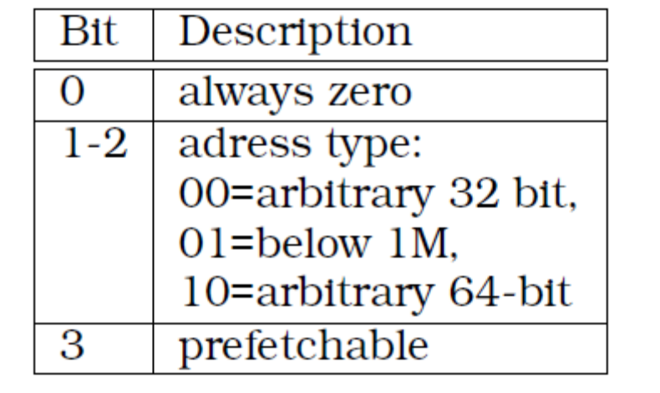
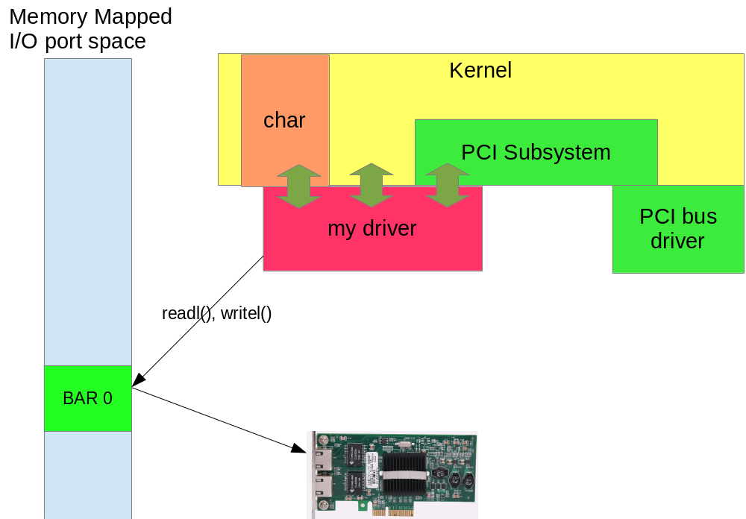

PCI I/O Address Space ( Mapping I/O Register as IO Ports)
- PCI supports 32-bit I/O space.
- Processors with special I/O instructions, like the Intel processor family, access the I/O space with in and out instructions.
- When the processor accesses the memory-mapped addresses, an I/O request will be sent to the PCI host bridge, which then translates the addresses into I/O cycles and puts them on the PCI bus.
- Will be deprecated in future released and probably will be removed from PCIe Later specs,
Cat /proc/ioports (???) will have i/o port mapping.
- IO_RESOURCE
- inb()/outb(),inw()/outw(),inl()/outl().
- Port Based IO Advantageous with CPU’s having limited addressing
- I/O space is required for operating the boot ROM for network adapters ,PXE Firmware.

lspci of PCI Parallel Port
PCI Parallel port that has only I/O Ports
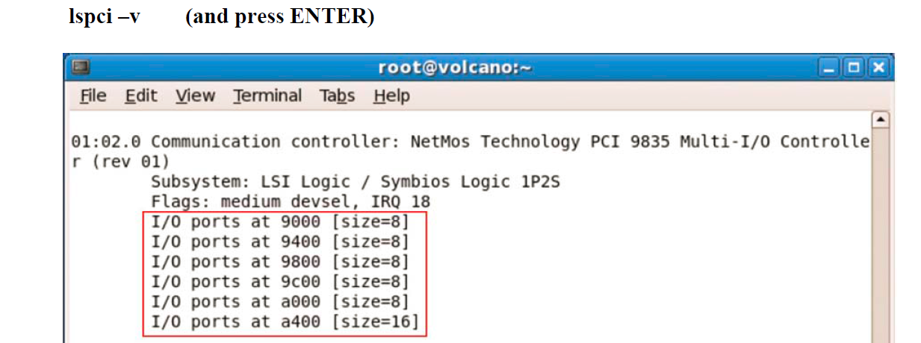

The above command indicates parallel ports 9000,...a400 with IRQ18.Default system PP is at 0x378

Finding Type of BAR
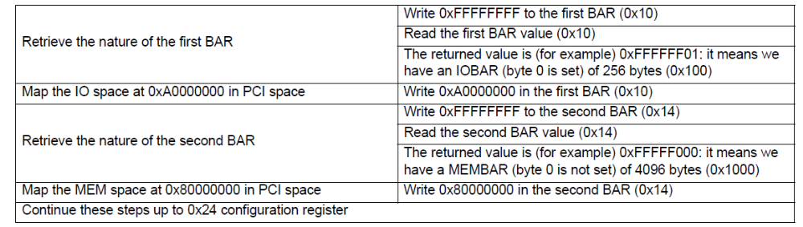

The BAR contains a PCI bus address .To use it we must have Virtual address, we get CPU physical address, which you get from pci_resource_start().Then we ioremap/pci_request_selected_regions() this physical address to get virtual address & Finally
this virtual address is read using readl/readw api.

PCIe message space
This is a new address space not previously implemented in PCI. This address space exists to eliminate the need for physical sideband signals. Therefore, everything that used to be implemented physically in previous bus protocols, such as the interrupt sideband signal, is now implemented as messages in the PCIe device tree.

BAR Management and Deciding Prefetchable and Non-prefetchable

IO Resource or MEM Resource
Write all 1s to a BAR and then read
If return value is all 0s then not used
If not zero, then check least sig bit
If 1 then IO assignment
If 0 then memory assignment
Bit position of least sig bit is used for size determination (i.e. if bit 6 is on decoder requires 26 or 64 bytes of space)

prefetchable vs no- prefetchable
If all 1s are written to a BAR and the return value is 0xFFFF0000
The BAR is a memory decoder
The BAR is not prefetchable
The BAR requires an address < 4GB
The BAR requires 216 or 64 KB of space
0xFFFF0008 as above but prefetchable
0xFFFF000A prefetchable and 64 bit
Length
If all 1s are written to a BAR and the return value is 0xFFFFF001
The BAR is an IO decoder
The BAR requires an address < 16 KB
The BAR requires 212 or 4 KB of space
Minimum memory size is 16 bytes
Minimum IO size is 4 bytes

PCI DMA Access

In PCI DMA happens through Bus Mastering , Which does involve third Party DMA Controller on Motherboard.
Conventional DMA is what is called third-party DMA, which means that the DMA controllers on the motherboard coordinate the DMA transfers. (The "third party" is the DMA controller.) Unfortunately, these DMA controllers are old and very slow--they are basically unchanged since the earliest days of the PC.
Modern IDE/ATA hard disks/PCI Devices use first-party DMA transfers. The term "first party" means that the peripheral device itself does the work of transferring data to and from memory, with no external DMA controller involved. This is also called bus mastering, because when such transfers are occurring the device becomes the "master of the bus".
If a device is busmaster capable the PCI COMMAND MASTER bit should have been set in the PCI COMMAND register.

Appendix

- Request bus master
- pci_set_master(pdev);
- Set the DMA mask
- if (dma_set_mask(&(pdev->dev), DMA_BIT_MASK(32))) {
- dev_err(&pdev->dev,"No suitable DMA available.\n");
- goto cleanup;
- }
- Request a DMA channel
- if (request_dma(dmachannel, DRIVER_NAME)) {
- dev_err(&pdev->dev,"Could not reserve DMA channel %d.\n", dmachannel);
- goto cleanup;
- }
- Map a buffer for DMA transfer
dma_handle = pci_map_single(pci_dev, buffer, count, DMA_TO_DEVICE);

Syncronous vs Asynchronous DMA
Synchronous DMA
The usual pattern of operations involved in synchronous DMA are:
1) A process requests a data transfer from/to a peripheral.
2) The device driver instructs the peripheral to transfer the data using a given memory buffer.
E.G
● When transmitting a packet to a LAN, network cards make use of synchronous DMA.

Async DMA
The usual pattern of operations involved in asynchronous DMA are:
1) The peripheral recognizes that some data is
available and raises an interrupt
2) The device driver's interrupt handler acknowledges the interrupt and instructs the peripheral to transfer the data into a given memory buffer
EG.
When receiving a packet from a LAN, network cards make use of asynchronous DMA.

The PCI bus implements DMA by allowing a device to become bus master. Once the component become bus master, it issues read and write commands on the PCI bus. The PCI controller claims these transactions and translates them to memory accesses.
An input/output memory management unit (IOMMU) [AMD, Int] translates memory addresses from an I/O bus to physical addresses in system memory. If an IOMMU is available, bus addresses have to be translated to physical addresses prior to a DMA-transfer .An IOMMU simplifies the design of user space drivers: buffers intended for DMA-transfer do not need to be physically contiguous anymore. The IOMMU is able to map fragmented, physical addresses to a coherent area in the bus address space.

MMU-Virtual TO Physical Address
IOMMU - IO Address to Physical Address

DMA mappings
The kernel defines an architecture-independent data type to store a bus address: dma_addr_t
Every buffer used for DMA transfers has to be associated both with a linear address (used by the CPU)
and with a bus address (used by the peripheral's DMA circuitry)
The kernel offers two kinds of mapping between linear addresses and bus addresses:
● Consistent DMA mappings
● Streaming DMA mappings

Consistent DMA mappings
A consistent DMA mapping is used whenever a DMA buffer has to be mapped forever. Examples:
● buffers for ring descriptors of network
cards
● buffers for SCSI command mailboxes
Both the CPU and the peripheral can access the buffer at the same point in time. However, any write
operation of the CPU should be immediately visible to the peripheral, and vice versa
Consistent DMA mappings have to be used sparingly, because in some architectures the amount of physical
addresses that can be mapped to bus addresses is limited.

To allocate a buffer and create a new consistent DMA mapping for it:
dma_addr_t busadd;
void * linadd;
struct pci_dev * pcidev;
linadd = pci_alloc_consistent(pcidev, size,&busadd);
To release a consistent DMA mapping and the buffer:
pci_free_consistent(pcidev, size,linadd, busadd);

Mailbox implementation- PSIF .

Streaming DMA mappings
A streaming DMA mapping is used whenever a DMA buffer has to be mapped for a limited time interval.
Examples:
● packet buffers for network cards
● filesystem buffers
● sound card buffers
In this mapping, CPU and peripheral cannot access the buffer at the same point in time
They are preferred over consistent DMA mappings because on many architectures they
ensure better performances.

The functions for streaming DMA mappings do not
allocate the buffer; it has to be done by the device
driver
A DMA buffer can be allocated by means of the:
● page allocator: alloc_pages(), __get_free_pages() ...
● generic memory allocator: kmalloc(),kmem_cache_alloc()
Use the GFP_DMA flag for allocating in the low 16 MB!

A DMA buffer cannot be:
● allocated at compile time
● allocated on the kernel stack

To create a new streaming DMA mapping for an already allocated buffer at linear address linbuf:
dma_addr_t busadd;
struct pci_dev pcidev;
busadd = pci_map_single(pcidev, linbuf,size, direction);
direction is one of the following:
PCI_DMA_TODEVICE
PCI_DMA_FROMDEVICE
PCI_DMA_BIDIRECTIONAL
PCI_DMA_NONE
To release a streaming DMA mapping (not the buffer!):
pci_unmap_single(pcidev,busadd,size,direction);

Once created a streaming DMA mapping for a
buffer:
● the device driver cannot access the buffer any more, until either the mapping is released or the
pci_dma_sync_single() function is invoked
● the device driver cannot release the mapping or invoke pci_dma_sync_single() until any DMA
data transfer on the buffer completes Therefore, in order to transfer data to a peripheral,
the device driver must first fill the buffer and then create the mapping.

Enable DMA by calling pci_set_master(). This will:
- Enable DMA by setting the bus master bit in the PCI_COMMAND register. The device will then be able to act as a master on the address bus.
- Fix the latency timer value if it's set to something bogus by the BIOS.
If the device can use the PCI MemoryWriteInvalidate transaction (writing entire cache lines), you can also call pci_set_mwi():
This enables the PCI_COMMAND bit for MemoryWriteInvalidate This also ensures that the cache line size register is set correctly.

Use pci_dma_set_mask() to declare any device with more (or less) than 32bit bus master capability.
e.g in PCI-X or PCIe Complaint devices which use 64-Bit DMA

If the device can directly address "consistent memory" in System RAM above 4G physical address, register this by calling pci_set_consistent_dma_mask().

err = pci_set_dma_mask(pdev, DMA_32BIT_MASK);
if (!err)
err = pci_set_consistent_dma_mask(pdev, DMA_32BIT_MASK);
if (err) {
printk(KERN_WARNING DRV_NAME ": No suitable DMA available.\n");
goto out_pci_disable_device;
}

1) How to allocate one DMA buffer:

vaddr = (unsigned long) dma_alloc_coherent(xdev->dev, size, paddr, GFP_KERNEL);
The return value is the virtual address of the allocated DMA buffer, and paddr stores the physical address of it. The FPGA chip DMA controller uses the paddr, while the kernel module uses the vaddr.

(2) After received the data from FPGA, call following function to invalidate the D-Cache:

dma_unmap_single(xdev->dev, paddr, length, DMA_FROM_DEVICE);
The paddr is the physical address of the DMA buffer.

(3) Before sending one buffer to FPGA, call following function to flush the D-cache:

paddr = dma_map_single(xdev->dev, vaddr, length, DMA_TO_DEVICE);
The paddr is the physical address of the DMA buffer, the vaddr is the virtual address of the DMA buffer.

(4) Get a receive buffer's physical address:

paddr = dma_map_single(xdev->dev, vaddr, length, DMA_FROM_DEVICE);
(5) How to free one DMA buffer:

dma_free_coherent(xdev->dev, size, vaddr, paddr);
The vaddr is the virtual address of the DMA buffer, whereas the paddr is the physical address.

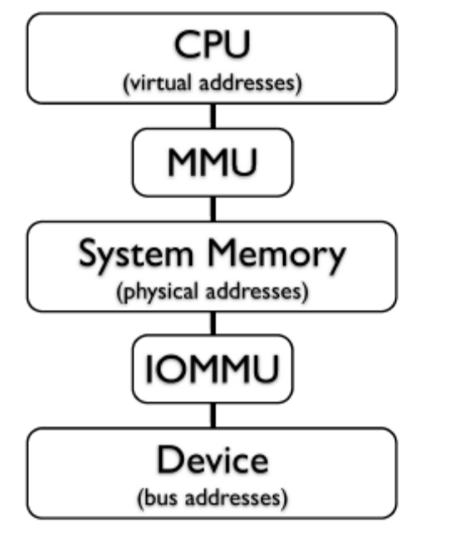

Interrupts in PCI
a) INT x
b) MSI /MSIx

Each PCI device has 4 different pins (lines)
for interrupt requests (IRQs): A,B,C,D
Why 4 pins? A single PCI device may sport
several peripherals (functions), and each
peripheral may need its own IRQ line

Every motherboard has a device called the Advance Programmable Interrupt Controller (APIC). This is the central location all devices must use when they wish to be serviced by the central processing unit (CPU).

PCI Int#A (PCI Slot 1)----------|==============|
|Programmable |
PCI Int#A (PCI Slot 2)----------| | Interrupt Line to CPU
|Interrupt |========>
PCI Int#A (PCI Slot 3)----------| |
|Controller |
|==============|

MSI do not use APIC.

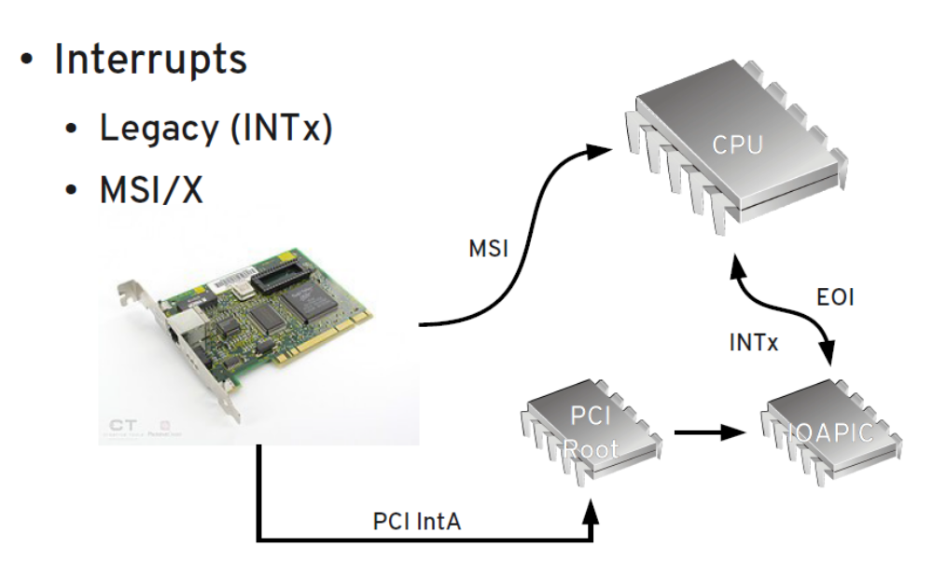

Interrupts
INTx
Conventional PCI introduced INTx.
There are 4 hard-wired Interrupt pins.
INTx is Level-triggered for robustness.

MSI (Message Signaled interrupt)
MSI is in-band method of signaling an interrupt by writing a data to specific memory regions.
MSI provides 32 interrupts.
There is a slight performance enhancement.

MSI-X
MSI-X provides up to 2048 interrupts.

Introduction of MSI
The PCI 2.2 specification introduced MSI as an alternative to traditional line-based interrupts. Instead of using a dedicated pin to trigger interrupts, MSI enables devices to trigger an interrupt by writing a specific value to a particular address. Note that the message destination address and message data are referred to as the “vector.” MSI provides the following key advantages over legacy interrupts:

 A PCI function can request up to 32 MSI messages
 They are in-band messages, instead of using pins, and
can target addresses in the host bridge
 They can send data along with the interrupt message
and the data payload can vary
 They are not shared, thus an MSI that is assigned to a
device is guaranteed to be unique within the system

Introduction of MSI-X
PCI 3.0 defines an extended form of MSI, called MSI-X, which addresses limiting features of MSI. For example, as NUMA-based servers supporting larger numbers of processors are more widely deployed, the current MSI limit of 32 MSI messages per adapter function is not
adequate. MSI-X addresses this limitation by increasing the number of messages to 2,048. Another example is that MSI provides only a single MSI address value such that all
messages are targeted at the same group of processors. MSI-X overcomes this issue by providing a unique address and data pair for each message. The core changes provided in PCI 3.0 for MSI-X are as follows:
 Supports 2,048 messages rather than 32 messages
 Supports an independent message address and
message data for each message
 Supports per-vector masking

The interrupt number is stored in configuration register 60 (PCI_INTERRUPT_LINE), which is one byte wide. This allows for as many as 256 interrupt lines, but the actual limit depends on the CPU being used. The driver doesn't need to bother checking the interrupt number, because the value found in PCI_INTERRUPT_LINE is guaranteed to be the right one.
If the device doesn't support interrupts, register 61 (PCI_INTERRUPT_PIN) is 0; otherwise, it's nonzero. However, since the driver knows if its device is interrupt driven or not, it doesn't usually need to read PCI_INTERRUPT_PIN.
Thus, PCI-specific code for dealing with interrupts just needs to read the configuration byte to obtain the interrupt number that is saved in a local variable, as shown in the following code. Beyond that, the information in Chapter 10 applies.
result = pci_read_config_byte(dev, PCI_INTERRUPT_LINE, &myirq);
if (result) {
/* deal with error */
}

Addresses on PCI are typically physical addresses (sometimes bus addresses); NEVER virtual addresses
Structure is struct pci_driver
Register a table of device ID's to identify
Kernel invokes probe() function when PCI device matching device ID is identified

Two functions needed to get the BAR ready for use:
pci_request_selected_regions()
ioremap()
This maps BAR into pci_device, then returns the start of the BAR (physical address)
Now readl() and writel() can be used to bang on the device

Must unregister from PCI layer
Functions to unwind:
iounmap()
pci_release_selected_regions()
These two must be called from remove function, NOT exit module
exit_module() must unregister pci_driver from PCI layer
/

MODULE_DEVICE_TABLE
This pci_device_id structure needs to be exported to user space to allow the hotplug and module loading systems know what module works with what hardware devices. The macro MODULE_DEVICE_TABLE accomplishes this. An example is:
MODULE_DEVICE_TABLE(pci, i810_ids);
This statement creates a local variable called _ _mod_pci_device_table that points to the list of struct pci_device_id. Later in the kernel build process, the depmod program searches all modules for the symbol _ _mod_pci_device_table. If that symbol is found, it pulls the data out of the module and adds it to the file /lib/modules/KERNEL_VERSION/modules.pcimap. After depmod completes, all PCI devices that are supported by modules in the kernel are listed, along with their module names, in that file. When the kernel tells the hotplug system that a new PCI device has been found, the hotplug system uses the modules.pcimap file to find the proper driver to load.

modules.pcimap file:
eepro100 0x00008086 0x00001229 0xffffffff 0xffffffff
0x00000000 0x00000000 0x00000000

PCIe Port Bus Driver

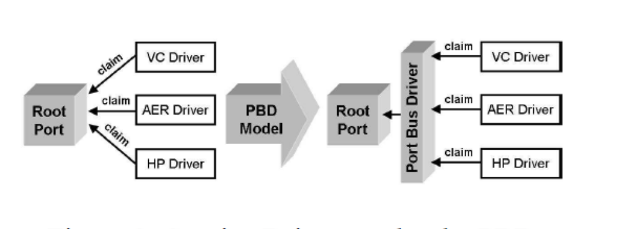

Linux PCI Driver Model | Linux PCIe Driver Model (Port Bus Driver)
-PCI restricts a device to a single Driver  -Once a driver is loaded , no other Drivers for that device can be loaded. | -PCIe has 4 Distinct services  1)Active Hotplug(HP)  2)Power Mgmt(PM)  3)Advanced error reporting(AER)  4)Virtual Channels(VC)  -To support Multipe PCI Driver per device PBD is designed  -PBD = Port Bus Driver  The PCI Express Port Bus Driver serves as a service manager  that loads and unloads the service drivers accordingly

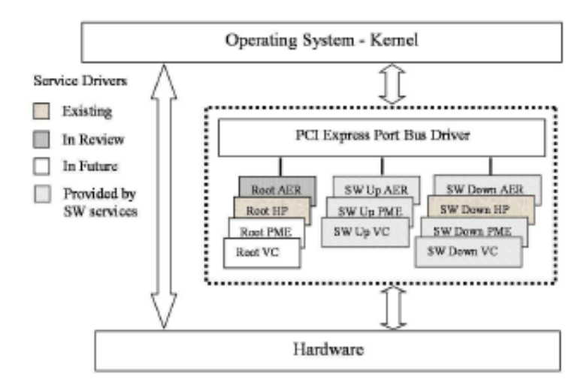

PCIe Driver can be made using existing PCI model or Using Sever Models of PBD.

SysFS PCI
In the Linux kernel, all device-configurations are known and exported to user space via sysfs.

Sysfs is an in-memory file system provided by the Linux 2.6 kernel. Sysfs exposes device information and attributes to user space. It provides an information channel from kernel to user space, allowing for device configuration Sysfs not only provide device configuration information such as I/O ports and memory mapped I/O regions, but also offer access to said resources.

Like most attributes in sysfs, the resource-attribute is an ASCII encoded file. It contains a line-based representation of the I/O regions used by the device. Consider Figure 2.6 for an example: every line defines an address range in Memory or I/O Address space. A definition consists of the first address, the last address, and properties. The address space of the mapping is encoded as fags. Along with every non-zero line in cat /sys/bus/pci/devices/0000:01:00.0/resource

0x0000000090200000 0x000000009021ffff 0x0000000000020200
0x0000000090100000 0x00000000901fffff 0x0000000000020200
0x0000000000002000 0x000000000000201f 0x0000000000020101
0x0000000000000000 0x0000000000000000 0x0000000000000000

Show BAR and resource in sysfs???

Accessing PCI from User space using Sysfs

After opening a file representing memory mapped I/O, the mmap system call is used to map the memory region in the address space of the calling process. Upon successful return, the I/O memory region can be accessed at the virtual address returned by the mmap system call. I/O space resources cannot be mapped into an address space, because special instructions are used to access I/O ports on the x86 architecture. Instead, after opening the I/O space resource file, it can be read from and written to, using the desired I/O port number as (file-)offset. For convenience the pread and pwrite system calls can be used. Sysfs conducts thorough range checks on the supplied I/O port argument before an I/O port access is executed

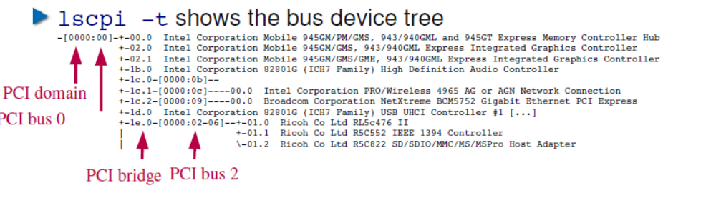
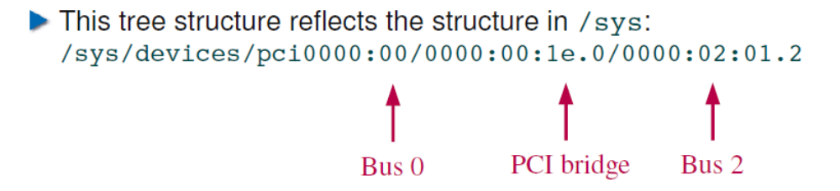

Manual driver binding and unbinding
(sysfs unbind method alternative to rmmod)
Useful in case there are two NIC both of same type and u want to unload driver only for second one.

https://www.kernel.org/doc/Documentation/ABI/testing/sysfs-bus-pci
What: /sys/bus/pci/drivers/.../bind
Description:
Writing a device location to this file will cause
the driver to attempt to bind to the device found at
this location. This is useful for overriding default
bindings. The format for the location is: DDDD:BB:DD.F.
That is Domain:Bus:Device.Function and is the same as
found in /sys/bus/pci/devices/. For example:
# echo 0000:00:19.0 > /sys/bus/pci/drivers/foo/bind
(Note: kernels before 2.6.28 may require echo -n).

What: /sys/bus/pci/drivers/.../unbind
Description:
Writing a device location to this file will cause the
driver to attempt to unbind from the device found at
this location. This may be useful when overriding default
bindings. The format for the location is: DDDD:BB:DD.F.
That is Domain:Bus:Device.Function and is the same as
found in /sys/bus/pci/devices/. For example:
# echo 0000:00:19.0 > /sys/bus/pci/drivers/foo/unbind
(Note: kernels before 2.6.28 may require echo -n).

One new feature in the 2.6.13-rc3 kernel release, is the ability to bind and unbind drivers from devices manually from user space. Previously, the only way to disconnect a driver from a device was usually to unload the whole driver from memory, using rmmod.
In the sysfs tree, every driver now has bind and unbind files associated with it:
$ tree /sys/bus/usb/drivers/ub/
/sys/bus/usb/drivers/ub/
|-- 1-1:1.0 -> ../../../../devices/pci0000:00/0000:00:1d.7/usb1/1-1/1-1:1.0
|-- bind
|-- module -> ../../../../module/ub
`-- unbind
In order to unbind a device from a driver, simply write the bus id of the device to the unbind file:
echo -n "1-1:1.0" > /sys/bus/usb/drivers/ub/unbind
and the device will no longer be bound to the driver:
$ tree /sys/bus/usb/drivers/ub/
/sys/bus/usb/drivers/ub/
|-- bind
|-- module -> ../../../../module/ub
`-- unbind

Writing PCI Device Driver

PCI Driver Flow
1. Fill up the pci_device_id table as follows.

static const struct pci_device_id pci_ids[] = {
{
.vendor = VENDOR_ID,
.device = DEVICE_ID,
.subvendor = PCI_ANY_ID,
.subdevice = PCI_ANY_ID,
.driver_data = (unsigned long) ~HOST_FORCE_PCI,
},

{ /* all zero 's */ },
};

2. This pci_device_id structure needs to be exported to user space to allow the hotplug
and module loading systems know what module works with what hardware devices.
The macro MODULE_DEVICE_TABLE accomplishes this.

An example is:
MODULE_DEVICE_TABLE(pci, pci_ids);

MODULE_DEVICE_TABLE(pci, i810_ids);
In the kernel build process, the depmod program searches all modules having MODUEL_DEVICE_TABLE adds it to the file/lib/modules/KERNEL_VERSION/modules.pcimap. After depmod completes, all PCI devices that are supported by modules in the kernel are listed, along with their module names, in that file. When the kernel tells the hotplug system that a new PCI device has been found, the hotplug system uses the modules.pcimap file to find the proper driver to load.

3. Fill the standard pci_driver structure with the PCI_id table,probe and remove functions.

say for example:

static struct pci_driver mypci_driver = {
.name = DRIVER_NAME,
.id_table = pci_ids,
.probe = mypci_probe,
.remove = __devexit_p(mypci_remove),
.suspend = NULL,
.resume = NULL,
};

The main structure that all PCI drivers must create in order to be registered with the kernel properly is the struct pci_driver structure. This structure consists of a number of function callbacks and variables that describe the PCI driver to the PCI core.

__devexit_p(x) expands to x if either the driver is included in a module or the kernel supports hotplugging, to NULL otherwise.

4. Registering a PCI Driver:

**To register the struct pci_driver with the PCI core, a call to pci_register_driver (for network register_netdev,for char misc_register,for block drivers register_blkdev) is made with a pointer to the struct pci_driver.

**This is traditionally done in the module initialization code for the PCI driver:

static int pci_init(void)
{
PRINT(" \n\nPCI DRIVER IS LOADED IN KERNEL SPACE \n\n");
return pci_register_driver(&mypci_driver);
}

**Note that the pci_register_driver function either returns a negative error number
or 0 if everything was registered successfully.

5.Initializing the Driver (Probe)
Probe function is called for every matching device id in pci_device_id table
a) initialize the driver's peripheral descriptor
b) allocate and initialize the device driver's data
structures
c) store the driver's peripheral descriptor (private data) address into
the pci_dev hardware device descriptor
d) enable the PCI peripheral
e) get the I/O address space
f) get the local memory address space
g) register the interrupt handler

6. Setting Private data structure
Typically this includes fields storing the assigned
resources, the address of memory buffers, usage
counters, and so on
struct privdata_t {
unsigned long ioadd;
unsigned long iolen;
unsigned long memadd;
unsigned long memlen;
void * memvadd;
int irq;
...
} privdata;

When the kernel's PCI layer invokes a method of our driver (for instance, remove), it provides a pointer to the pci_dev descriptor of the PCI peripheral

In general, a device driver can handle several PCI peripheral of the same type, if present In such cases, we have to allocate several peripheral descriptors In order to get the address of the corresponding peripheral descriptor, probe() stores it into the pci_dev data structure:
pci_set_drvdata(pcidev, &privdata);

5.Accessing PCI configuration space:

The configuration space can be accessed through 8-bit, 16-bit, or 32-bit data transfers at any time.
The relevant functions are prototyped in <linux/pci.h>:

int pci_read_config_byte(struct pci_dev *dev, int where, u8 *val);
int pci_read_config_word(struct pci_dev *dev, int where, u16 *val);
int pci_read_config_dword(struct pci_dev *dev, int where, u32 *val);
int pci_write_config_byte(struct pci_dev *dev, int where, u8 val);
int pci_write_config_word(struct pci_dev *dev, int where, u16 val);
int pci_write_config_dword(struct pci_dev *dev, int where, u32 val);
e,g
/* Clear "detected parity error" bit*/
pci_write_config_word(sp>pdev, PCI_STATUS, 0x8000);

6. Enabling the PCI Device:

**In the probe function for the PCI driver, before the driver can access any device resource
(I/O region or interrupt) of the PCI device, the driver must call the pci_enable_device
function:

**int pci_enable_device(struct pci_dev *dev);

**This function actually enables the device. It wakes up the device and in some cases also assigns its interrupt line and I/O regions.

struct pci_dev {
struct list_head global_list; /* node in list of all PCI devices */
struct list_head bus_list; /* node in per-bus list */
struct pci_bus *bus; /* bus this device is on */
struct pci_bus *subordinate; /* bus this device bridges to */

void *sysdata; /* hook for sys-specific extension */
struct proc_dir_entry *procent; /* device entry in /proc/bus/pci */

unsigned int devfn; /* encoded device & function index */
unsigned short vendor;
unsigned short device;
unsigned short subsystem_vendor;
unsigned short subsystem_device;
unsigned int class; /* 3 bytes: (base,sub,prog-if) */
u8 hdr_type; /* PCI header type (`multi' flag masked out) */
u8 rom_base_reg; /* which config register controls the ROM */
u8 pin; /* which interrupt pin this device uses */

struct pci_driver *driver; /* which driver has allocated this device */
u64 dma_mask; /* Mask of the bits of bus address this
device implements. Normally this is
0xffffffff. You only need to change
this if your device has broken DMA
or supports 64-bit transfers. */

pci_power_t current_state; /* Current operating state. In ACPI-speak,
this is D0-D3, D0 being fully functional,
and D3 being off. */

pci_channel_state_t error_state; /* current connectivity state */
struct device dev; /* Generic device interface */

/* device is compatible with these IDs */
unsigned short vendor_compatible[DEVICE_COUNT_COMPATIBLE];
unsigned short device_compatible[DEVICE_COUNT_COMPATIBLE];

int cfg_size; /* Size of configuration space */

/*
* Instead of touching interrupt line and base address registers
* directly, use the values stored here. They might be different!
*/
unsigned int irq;
struct resource resource[DEVICE_COUNT_RESOURCE]; /* I/O and memory regions + expansion ROMs */

/* These fields are used by common fixups */
unsigned int transparent:1; /* Transparent PCI bridge */
unsigned int multifunction:1;/* Part of multi-function device */
/* keep track of device state */
unsigned int is_enabled:1; /* pci_enable_device has been called */
unsigned int is_busmaster:1; /* device is busmaster */
unsigned int no_msi:1; /* device may not use msi */
unsigned int block_ucfg_access:1; /* userspace config space access is blocked */

u32 saved_config_space[16]; /* config space saved at suspend time */
struct hlist_head saved_cap_space;
struct bin_attribute *rom_attr; /* attribute descriptor for sysfs ROM entry */
int rom_attr_enabled; /* has display of the rom attribute been enabled? */
struct bin_attribute *res_attr[DEVICE_COUNT_RESOURCE]; /* sysfs file for resources */
};

7.Enabling the PCI-Bus mastering for the device by calling pci_set_master Kernel API.
This API enables bus-mastering on the device and calls pcibios_set_master to do the needed arch specific settings
It is done in the driver, if it is needed.

**Bus Mastering:
bus mastering is the capability of devices on the PCI bus (other than the system chipset, of course) to
take control of the bus and perform transfers directly. PCI's design allows bus mastering of multiple devices on the bus simultaneously,
with the arbitration circuitry working to ensure that no device on the bus (including the processor!) locks out any other device.
At the same time though, it allows any given device to use the full bus throughput if no other device needs to transfer anything.

**PCI transactions work in a master-slave relationship. A master is an agent that initiates a transaction (can be a read or a write).
While the host CPU is often the bus master, all PCI boards can potentially claim the bus and become a bus master.

**When a PCI device is enabled, it's bus mastering is also enabled. This occurs before any driver code is
executed.

8. Accessing Memory Regions

BAR contains BUS Address, pci_resource_start gives Physical Address.

**unsigned long pci_resource_start(struct pci_dev *dev, int bar);
The function returns the first address (memory address or I/O port number)
associated with one of the six PCI I/O regions. The region is selected by the integer
bar (the base address register), ranging from 0–5 (inclusive).

**unsigned long pci_resource_end(struct pci_dev *dev, int bar);
The function returns the last address that is part of the I/O region number bar.
Note that this is the last usable address, not the first address after the region.

**unsigned long pci_resource_flags(struct pci_dev *dev, int bar);
This function returns the flags associated with this resource.
All resource flags are defined in <linux/ioport.h>; the most important are:
IORESOURCE_IO
IORESOURCE_MEM ( if the resource type is memory resource, then we can access the register by means of readl/b/w/writel/b/w functions)

#define pci_resource_start(dev,bar) ((dev)->resource[(bar)].start)
#define pci_resource_end(dev,bar) ((dev)->resource[(bar)].end)
#define pci_resource_flags(dev,bar) ((dev)->resource[(bar)].flags)
#define pci_resource_len(dev,bar) \
((pci_resource_start((dev),(bar)) == 0 && \
pci_resource_end((dev),(bar)) == \
pci_resource_start((dev),(bar))) ? 0 : \
\
(pci_resource_end((dev),(bar)) - \
pci_resource_start((dev),(bar)) + 1))

Other Flags
If the associated I/O region exists, one and only one of these flags is set.
IORESOURCE_PREFETCH
IORESOURCE_READONLY
These flags tell whether a memory region is prefetchable and/or write protected. The latter flag is never set for PCI resources.

9.Reserving the PCI I/O and memory regions.

int pci_request_region (struct pci_dev * pdev, int bar, char * res_name);

Arguments:
pdev
PCI device whose resources are to be reserved
bar
BAR to be reserved
res_name
Name to be associated with resource.

Description
Mark the PCI region associated with PCI device pdev BR bar as being reserved by owner res_name.
Do not access any address inside the PCI regions unless this call returns successfully.

- Need to use ioremap() to map this into a virtual memory address. Use ioread8(), iowrite8(), memset_io(), memset_toio() and memset_fromio() to access it.

Requesting IO Ports
register_chrdev (0, "memIO_device", &fops)
check_region(start,length)
request_region(start,lenght," memIO_device ");
release_region(start,length);

E.G:.request_region(0xd260,0x4," memIO_device ");
root@alok-laptop:~/ksrc/pci# cat /proc/ioports
0000-001f : dma1
0020-0021 : pic1
0040-0043 : timer0
0050-0053 : timer1
0060-0060 : keyboard
0064-0064 : keyboard
0070-0071 : rtc_cmos
0070-0071 : rtc0
d260-d263 : memIO_device

Now to Get start and End Address of memory we should use
privdata.memadd=pci_resource_start(pcidev,BARO);
privdata.memlen=pci_resource_len(pcidev,BAR0);
( Assuming BAR0 is IO_RESOURCE)
request_region(privdata.memadd,privdata.memlen,"my_driver");

Requesting Memory Space
register_chrdev (0, "memIO_device", &fops)
check_mem_region(start,length)
request_mem_region(start,lenght," memIO_device ");
release_mem_region(start,length);

E.G: request_mem_region(0xf0842000, 0xeed,"memIO_device");
root@alok-laptop:~/ksrc/pci# cat /proc/iomem
00000000-00001fff : System RAM
00002000-00005fff : reserved
00006000-0009fbff : System RAM
0009fc00-0009ffff : reserved
000a0000-000bffff : Video RAM area
f0842000-f0842eec : memIO_device
fee00000-fee00fff : Local APIC
fffc0000-ffffffff : reserved

Now to Get start and End Address of memory we should use
privdata.memadd=pci_resource_start(pcidev,BAR1);
privdata.memlen=pci_resource_len(pcidev,BAR1);
( Assuming BAR0 is MEM_RESOURCE)
request_mem_region(privdata.memadd,privdata.memlen,"my_driver");

10. Converting physical address to virtual address.

Above addresses are Physical Address before using these address we must remap them into the kernel virtual address space by using ioremap() or ioremap_nochache():

pci.pVirtualBaseAddr=(unsigned int *)ioremap_nocache(pci.PciBaseStart,pci.length);

11. removing Driver

free_irq(dev->irq, privdata);
iounmap(privdata->memvadd);
release_mem_region(privdata->memadd,privdata->memlen);
release_region(privdata->ioadd, privdata->iolen);

Things todo in Probe

a) initialize the driver's peripheral descriptor
b) allocate and initialize the device driver's data
structures
c) store the driver's peripheral descriptor address into
the pci_dev hardware device descriptor
d) enable the PCI peripheral
e) get the I/O address space
f) get the local memory address space
g) register the interrupt handler

driver's peripheral descriptor is a private data structure defined by you that should include the information
required to drive the peripheral Typically it includes fields storing the assigned
resources, the address of memory buffers, usage counters, and so on
struct privdata_t {
unsigned long ioadd;
unsigned long iolen;
unsigned long memadd;
unsigned long memlen;
void * memvadd;
int irq;
unit32 semaphore,spinlock
...
} privdata;

How PCI device works
-The BAR address space (mapped in memory or I/O space) is
used for control registers
-The driver allocates buffers in RAM
-The addresses of these buffers are written in control registers
-The device reads and writes from the buffer via DMA
-All this it timed and orchestrated via control registers
... and interrupts

Use of mmiowb/add io barriers, remove mmiowb after Write to PCI device

Driver sequence
1.Probe

The probe() function is invoked by the kernel's PCI layer once for every PCI peripheral whose
identifiers match those specified in the pci_device_id table

Tthe probing function is called for all existing PCI devices that are not owned by the other drivers yet. So, even if you have the correct vendor and device IDs you will not see the function being called if the device is owned by another driver. To see which drivers own which devices run:
lspci -knn

kzalloc buffer
pci_set_data(buffer)
pci_enable_device

rc = pci_request_regions(pdev, "foo");
After this, “foo” will show up in /proc/iomem

Assuming that our device’s configuration header requests 128 bytes
on BAR 0:
privdata->registers = pci_iomap(pdev, 0, 128);
if (!privdata->registers) {
printk(KERN_ERR "foo: Failed to map BAR 0.\n");
goto failed_iomap0;
}
iowrite32(1, &privdata->registers[0x10]);
mmiowb(); /* Some holy water never hurts */
2.Enabling Master and MSI
pci_set_master(pdev);
/* Set up a single MSI interrupt */
if (pci_enable_msi(pdev)) {
printk(KERN_ERR "foo: Failed to enable MSI.\n");
rc = -ENODEV;
goto failed_enable_msi;
}

3.32 or 64 Bit Access DMA Access

if (!pci_set_dma_mask(pdev, DMA_BIT_MASK(64)))
privdata->dma_using_dac = 1;
else if (!pci_set_dma_mask(pdev, DMA_BIT_MASK(32)))
privdata->dma_using_dac = 0;
else {
printk(KERN_ERR "foo: Failed to set DMA mask.\n");
rc = -ENODEV;
goto failed_dmamask;
}
Eli

pci_enable_device
pci_request_selected_regions
pci_iomap

Probe is callled once for each matching device present in the table,It is called when drivers registers
Also when new matching device is inserted.

The __devexit_p is a macro turning into NULL when the module is compiled into the kernel itself (as opposed loadable module) and isn’t hotpluggable. Since the module can’t ever exit, this gives the compiler an opportunity to optimize away the function alltogether

__get_free_page(s) vs. alloc_page(s)
That’s confusing. Both get you either one page of PAGE_SIZE of memory (4096 bytes in most cases), or several of them (the -s versions), but __get_free_pages returns the actual address as kmalloc, while alloc_pages returns page information via a struct page pointer. For DMA, the former’s memory chunk is mapped with e.g. pci_map_single(), but the latter with dma_map_page().
PCI Private data
If the probe succeeds, it also does whatever per-device initialization is required, including creation of a driver-specific structure btv, and hangs a pointer this driver-specific data on the "hook" of the struct pci_devobject corresponding to dev via a call to pci_set_drvdata

LINUX PCI API

Exploration of bus/attached devices and drivers
struct pci_driver * | pci_dev_driver (const struct pci_dev *dev)
 | Get PCI driver of given device.
int | pci_register_driver (struct pci_driver *drv)
 | Register PCI driver.
void | pci_unregister_driver (struct pci_driver *drv)
 | Unregister PCI driver.
struct pci_dev * | pci_find_device (unsigned int vendor, unsigned int device, const struct pci_dev *from)
 | Find PCI Device on vendor and device IDs.
struct pci_dev * | pci_find_subsys (unsigned int vendor, unsigned int device, unsigned int ss_vendor, unsigned int ss_device, const struct pci_dev *from)
 | Find PCI Device on vendor, subvendor, device and subdevice IDs.
struct pci_dev * | pci_find_slot (unsigned int bus, unsigned int devfn)
 | Find PCI Device on Slot.
struct pci_dev * | pci_find_class (unsigned int class, const struct pci_dev *from)
 | Find PCI Device on Class.

Device setup (bus mastering, enable/disable)
int | pci_enable_device (struct pci_dev *dev)
 | Enable PCI Device.May assign IRQ and IO Regions
void | pci_disable_device (struct pci_dev *dev)
 | Disable PCI Device.
void | pci_set_master (struct pci_dev *dev)
 | Set Busmastering for PCI Device.
int | pci_set_mwi (struct pci_dev *dev)
 | FIXME Dummy (could also go into L4IO.
void | pci_clear_mwi (struct pci_dev *dev)
 | FIXME Dummy (should also go into L4IO.

Power Management related functions
int | pci_set_power_state (struct pci_dev *dev, int state)
 | Set PM State for PCI Device.
int | pci_enable_wake (struct pci_dev *dev, u32 state, int enable)
 | FIXME Dummy (could also go into L4IO.
int | pci_save_state (struct pci_dev *dev, u32 *buffer)
 | FIXME Dummy (could also go into L4IO.
int | pci_restore_state (struct pci_dev *dev, u32 *buffer)
 | FIXME Dummy (could also go into L4IO.

PCI memory pools (consistent DMA mappings...)
Pool allocator .
.. wraps the pci_alloc_consistent page allocator, so small blocks are easily used by drivers for bus mastering controllers. This should probably be sharing the guts of the slab allocator.
struct pci_pool * | pci_pool_create (const char *name, struct pci_dev *pdev, size_t size, size_t align, size_t allocation, int flags)
 | Create a pool of pci consistent memory blocks, for dma.
void | pci_pool_destroy (struct pci_pool *pool)
 | Destroy a pool of pci memory blocks.
void * | pci_pool_alloc (struct pci_pool *pool, int mem_flags, dma_addr_t *handle)
 | Get a block of consistent memory.
void * | pci_alloc_consistent (struct pci_dev *hwdev, size_t size, dma_addr_t *dma_handle)
 | Allocation of PCI consistent DMA Memory.
void | pci_free_consistent (struct pci_dev *hwdev, size_t size, void *vaddr, dma_addr_t dma_handle)
 | Deallocation of PCI consistent DMA Memory.

Configuration space access
int | pci_read_config_byte (struct pci_dev *dev, int pos, l4_uint8_t *val)
 | PCI Configuration Space access - read byte.
int | pci_read_config_word (struct pci_dev *dev, int pos, l4_uint16_t *val)
 | PCI Configuration Space access - read word.
int | pci_read_config_dword (struct pci_dev *dev, int pos, l4_uint32_t *val)
 | PCI Configuration Space access - read double word.
int | pci_write_config_byte (struct pci_dev *dev, int pos, l4_uint8_t val)
 | PCI Configuration Space access - write byte.
int | pci_write_config_word (struct pci_dev *dev, int pos, l4_uint16_t val)
 | PCI Configuration Space access - write word.
int | pci_write_config_dword (struct pci_dev *dev, int pos, l4_uint32_t val)
 | PCI Configuration Space access - write double word.

SETPCI Command

[root@lab01 ~]# lspci -s 07:00.0 -x
07:00.0 Ethernet controller: Intel Corporation 82576 Gigabit Network Connection (rev 01)
00: 86 80 c9 10 47 05 10 00 01 00 00 02 40 00 80 00
10: 00 00 52 df 00 00 50 df 81 c8 00 00 00 c0 4f df
20: 00 00 00 00 00 00 00 00 00 00 00 00 8e 10 4c 48
30: 00 00 4c df 40 00 00 00 00 00 00 00 0a 01 00 00

[root@lab01 ~]# setpci -v -d 8086:10c9 BASE_ADDRESS_0 BASE_ADDRESS_1
0000:07:00.1 @10 = df5e0000
0000:07:00.1 @14 = df5c0000
0000:07:00.0 @10 = df520000
0000:07:00.0 @14 = df500000
0000:01:00.1 @10 = df3e0000
0000:01:00.1 @14 = df3c0000
0000:01:00.0 @10 = df320000
0000:01:00.0 @14 = df300000

[root@lab01 ~]# setpci --dumpregs
cap pos w name
00 W VENDOR_ID
02 W DEVICE_ID
04 W COMMAND
06 W STATUS
08 B REVISION
09 B CLASS_PROG
0a W CLASS_DEVICE
0c B CACHE_LINE_SIZE
0d B LATENCY_TIMER
0e B HEADER_TYPE
0f B BIST
10 L BASE_ADDRESS_0
14 L BASE_ADDRESS_1
18 L BASE_ADDRESS_2
1c L BASE_ADDRESS_3
20 L BASE_ADDRESS_4
24 L BASE_ADDRESS_5
28 L CARDBUS_CIS
2c L SUBSYSTEM_VENDOR_ID
2e W SUBSYSTEM_ID
30 L ROM_ADDRESS
3c B INTERRUPT_LINE
3d B INTERRUPT_PIN
3e B MIN_GNT
3f B MAX_LAT
18 B PRIMARY_BUS
19 B SECONDARY_BUS
1a B SUBORDINATE_BUS
1b B SEC_LATENCY_TIMER
1c B IO_BASE
1d B IO_LIMIT
1e W SEC_STATUS
20 W MEMORY_BASE
22 W MEMORY_LIMIT
24 W PREF_MEMORY_BASE
26 W PREF_MEMORY_LIMIT
28 L PREF_BASE_UPPER32
2c L PREF_LIMIT_UPPER32
30 W IO_BASE_UPPER16
32 W IO_LIMIT_UPPER16
38 L BRIDGE_ROM_ADDRESS
3e W BRIDGE_CONTROL
10 L CB_CARDBUS_BASE
14 W CB_CAPABILITIES
16 W CB_SEC_STATUS
18 B CB_BUS_NUMBER
19 B CB_CARDBUS_NUMBER
1a B CB_SUBORDINATE_BUS
1b B CB_CARDBUS_LATENCY
1c L CB_MEMORY_BASE_0
20 L CB_MEMORY_LIMIT_0
24 L CB_MEMORY_BASE_1
28 L CB_MEMORY_LIMIT_1
2c W CB_IO_BASE_0
2e W CB_IO_BASE_0_HI
30 W CB_IO_LIMIT_0
32 W CB_IO_LIMIT_0_HI
34 W CB_IO_BASE_1
36 W CB_IO_BASE_1_HI
38 W CB_IO_LIMIT_1
3a W CB_IO_LIMIT_1_HI
40 W CB_SUBSYSTEM_VENDOR_ID
42 W CB_SUBSYSTEM_ID
44 L CB_LEGACY_MODE_BASE
01 00 - CAP_PM
02 00 - CAP_AGP
03 00 - CAP_VPD
04 00 - CAP_SLOTID
05 00 - CAP_MSI
06 00 - CAP_CHSWP
07 00 - CAP_PCIX
08 00 - CAP_HT
09 00 - CAP_VNDR
0a 00 - CAP_DBG
0b 00 - CAP_CCRC
0c 00 - CAP_HOTPLUG
0d 00 - CAP_SSVID
0e 00 - CAP_AGP3
0f 00 - CAP_SECURE
10 00 - CAP_EXP
11 00 - CAP_MSIX
12 00 - CAP_SATA
13 00 - CAP_AF
0001 00 - ECAP_AER
0002 00 - ECAP_VC
0003 00 - ECAP_DSN
0004 00 - ECAP_PB
0005 00 - ECAP_RCLINK
0006 00 - ECAP_RCILINK
0007 00 - ECAP_RCECOLL
0008 00 - ECAP_MFVC
000a 00 - ECAP_RBCB
000b 00 - ECAP_VNDR
000d 00 - ECAP_ACS
000e 00 - ECAP_ARI
000f 00 - ECAP_ATS
0010 00 - ECAP_SRIOV

